Phase 3: System Design

Student No: 202321283
Surname: MOKHABI
Project: Moderated Learning Management System (MLMS)
Development model: Waterfall, with V-Model verification and validation
Date: 16/10/2026
Week No: 3

Introduction
This document is the Phase 3 deliverable for the Moderated LMS. It covers three marked components:
- Architecture: architectural style, component diagram, design rationale with a rejected alternative
- Class Diagram: design-level class diagram with two or more design patterns and SOLID justification
- Behavioral Models: state machine, activity diagram with swimlanes, and two sequence diagrams
- Database Design: ERD normalized to 3NF, data dictionary, SQL schema, and class-to-table mapping
The design is derived from the Phase 2 SRS and resolves the conflicts and ambiguities recorded there. Every design element is traceable to at least one requirement, use case or business rule.

Architecture

Selected Architectural Style: Layered Architecture
Layered architecture organizes a software system into separate layers, each responsible for specific functions. The system is decomposed into four horizontal layers:
- Presentation Layer: Displays console menus, capture input and report errors in plaintext.
- Business Logic Layer: Handles login, role-based permissions, course management, assignment submission, marking, marks moderation etc.
- Data Access Layer: Executes database operations and retrieves or updates records.
- Database Layer: Stores user accounts, courses, assignments, marks, and moderation records etc.
Functionalities such as logging, input validation, exception translation, password hashing are handled in dedicated helper classes used by the layers above.

Justification
Layered architecture organizes a software system into separate layers, each responsible for specific functions It is suitable for the console-based Moderated Learning Management System (MLMS) because it promotes:
- Separation of concerns: Separates the console interface, business logic, database access, and data storage, making the system easier to understand and manage.
- Maintainability: Changes to one layer can be made with minimal impact on other layers, provided the interfaces between them remain consistent.
- Security: Centralizes authentication, role-based access control, and moderation rules in the business logic layer to protect student information and learning materials.
- Testability: Each layer can be tested independently, making it easier to identify and correct errors.
- Reusability: Business logic and data access components can be reused if the console interface is replaced with a graphical or web interface.
- Scalability and extensibility: New features, such as online payment, video conferencing, automated grading, plagiarism detection, and web or mobile interfaces, can be introduced without redesigning the entire system.
- Data integrity: The data access layer helps control database operations and supports consistent storage and retrieval of student records, marks, and assignments.

component diagram
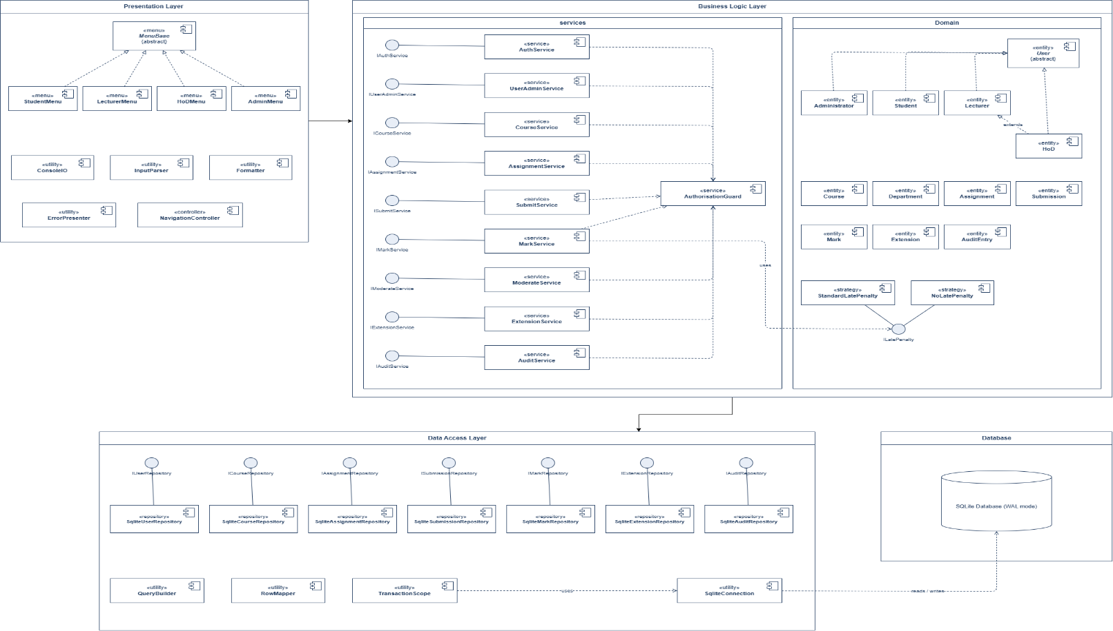

Rejected alternative: Model–View–Controller (MVC)
MVC was considered and rejected because MVC is a common choice for interactive applications, and the case study allows a simple desktop GUI, which suits MVC's view separation. However, layered architecture fits this project better. First, the console is simply another presentation layer, while MVC expects a richer view layer with widgets and bindings, so a console maps awkwardly onto MVC. Second, the domain layer stays pure and easy to test, but MVC controllers tend to absorb logic and become harder to test on their own. Third, layering keeps all SQL in one repository layer, whereas MVC persistence often leaks into the model and risks breaking the data-access rule. Fourth, each layer maps cleanly to a V-Model test level, but MVC blurs the line between unit and integration testing. Finally, layering is simpler for a single developer, while MVC forces us to wire observers, controllers and views even for simple flows. In short, for an offline console application with strict testability, security and data-access needs, layering is the better choice, and MVC would only add complexity without a matching benefit.

Class Diagram

Design-Level Class Diagram
The diagram below shows visibility (+ public, - private, # protected), types, multiplicities, inheritance, interfaces
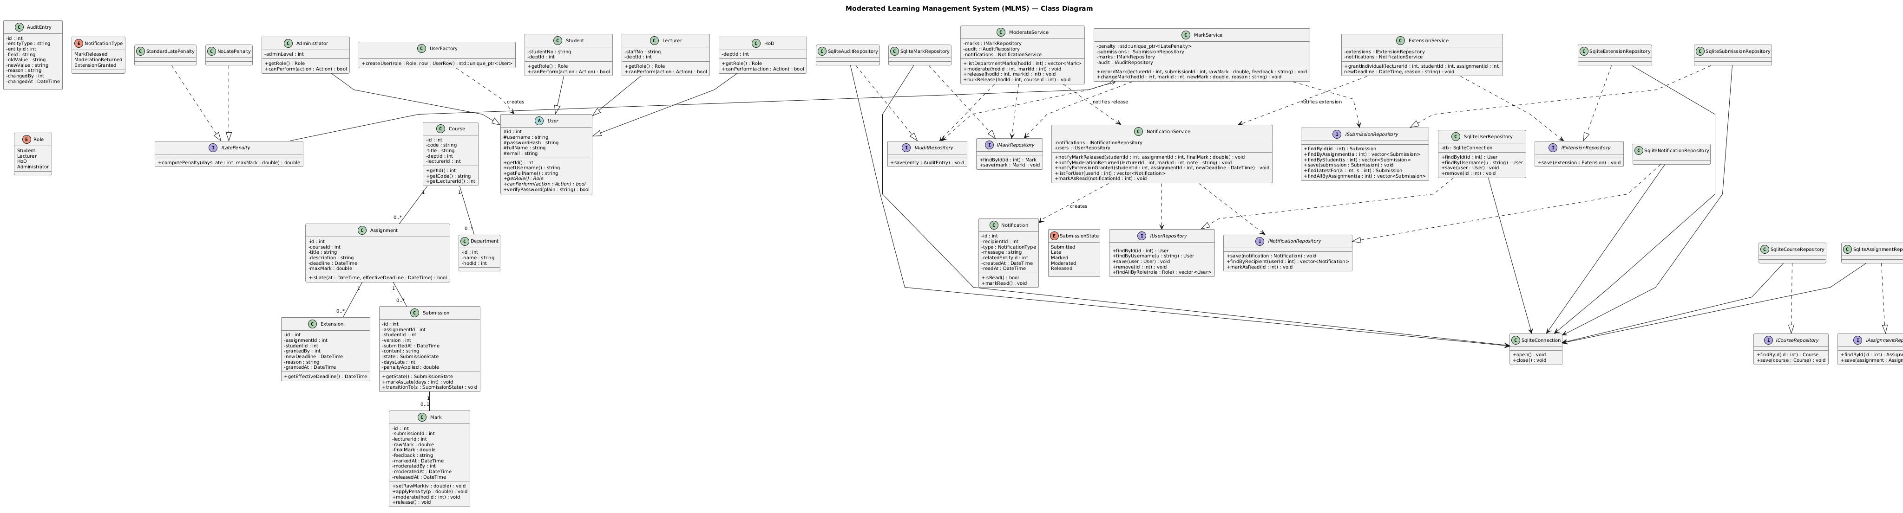

Design Patterns Applied
Pattern | Applied Where | Why it was chosen
Strategy | ILatePenalty, StandardLatePenalty, NoLatePenalty and  MarkService | The HoD's late-penalty rule is a policy that may change. Encapsulating it behind an interface means the rule can be swapped or extended without modifying MarkService, satisfying the Open/Closed Principle. It also makes boundary testing trivial: NoLatePenalty lets tests isolate marking from penalty logic.
Repository / DAO | ISubmissionRepository and SqliteSubmissionRepository | It isolates all SQL in the Data layer, so the Domain layer is pure C++ and unit-testable without SQLite (NFR-10). It also enforces parameterized queries in a single place (NFR-05), which is easy to check with static analysis.
Factory | UserFactory | User rows are read as raw data from SQLite; converting them into the right Student, Lecturer, HoD or Administrator object is a single decision point. A Factory keeps this logic out of the repository and makes it easy to test. It also pairs naturally with the User inheritance hierarchy and would generalize to new roles.
Observer | NotificationService and ModerationService | ModerationService must notify students when a mark is released without knowing how notifications are stored or shown. The Observer pattern lets ModerationService publish a "mark released" event and NotificationService subscribe to it, so the two-stay decoupled. New observers (e.g. email later) can be added without changing ModerationService, satisfying the Open/Closed Principle.

SOLID Principles in the Design
Principle | How the design satisfies it
Single Responsibility | Each class has one reason to change: MarkService for marking, AuditService for auditing, SqliteUserRepository for user persistence, StandardLatePenalty for penalty arithmetic.
Open/Closed | New penalty rules are added as new ILatePenalty implementations; new user roles are added as new User subclasses with a new UserFactory branch.
Liskov Substitution | All User subclasses are usable wherever User is expected; canPerform and getRole are pure virtual and every subclass honours the contract.
Interface Segregation | Repository interfaces are split per entity (IUserRepository, ISubmissionRepository, etc.) so no client is forced to depend on methods it does not use.
Dependency Inversion | MarkService, AuthService and the other services depend on repository interfaces, not on SqliteXRepository. This is what enables unit tests without a database.

Behavioral Models

State Machine Diagram - Submission Life Cycle
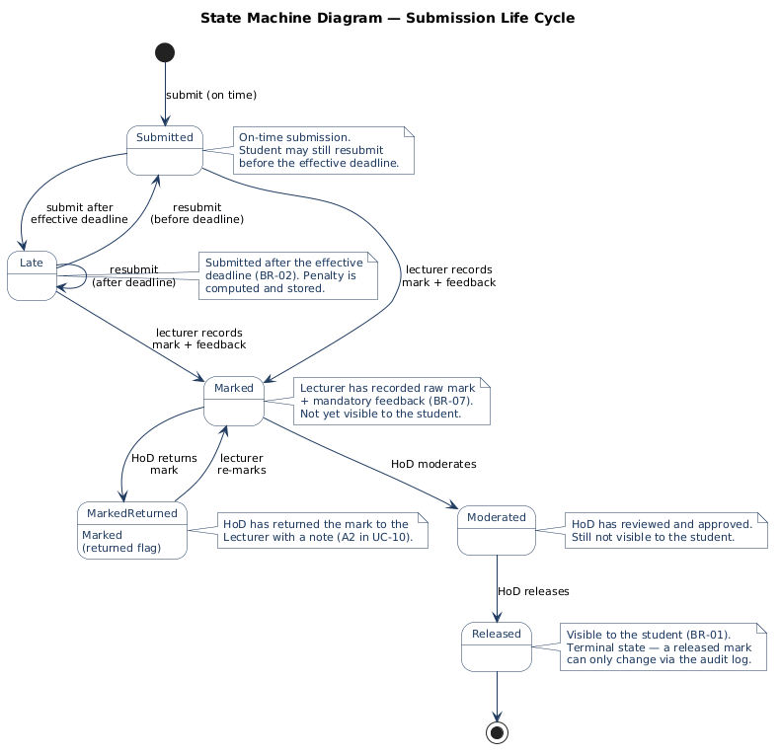
The state machine diagram models how a student submission moves through the MLMS life cycle. A submission starts at the initial pseudo state and enters Submitted if the student submits on time, or Late if they submit after the effective deadline. From Late, the student may resubmit before the deadline (returning to Submitted) or resubmit after the deadline (staying in Late). Once the lecturer records a raw mark and mandatory feedback, the submission moves to Marked, where it is still invisible to the student. If the HoD returns the mark for correction, it enters Marked (returned flag) and returns to Marked when the lecturer re-marks it. When the HoD moderates the mark, it moves to Moderated, and when the HoD releases it, it becomes Released, which is the terminal state and the only state in which the student can see the mark and feedback.

Activity diagram - swimlanes from submission to released mark
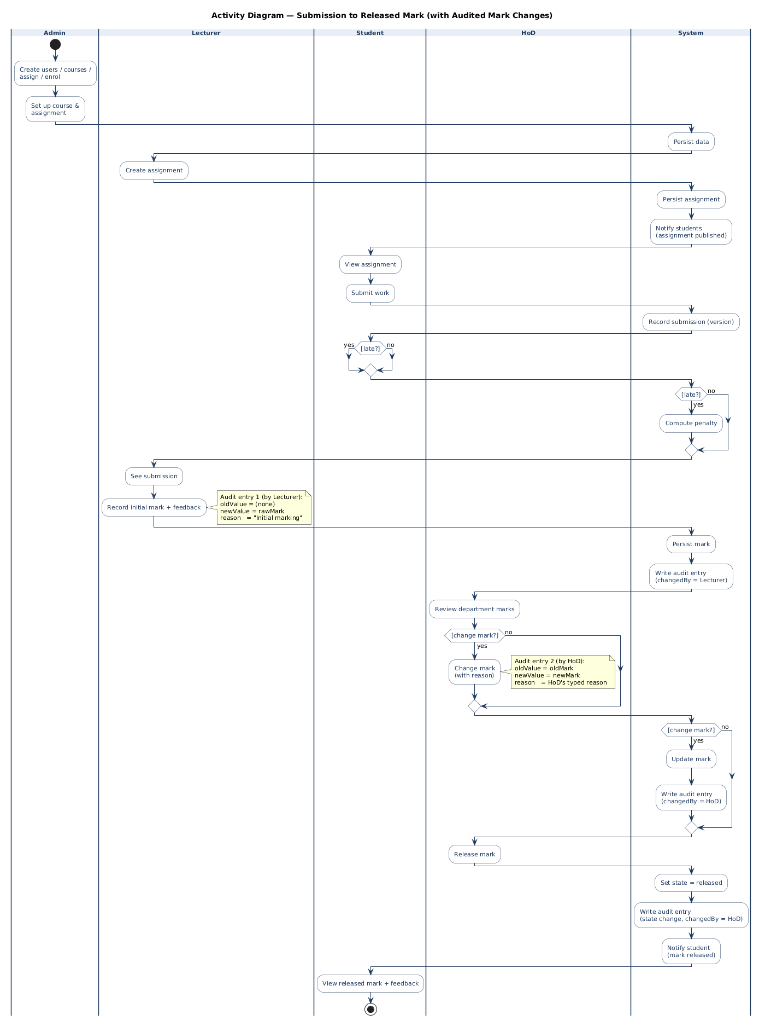

Sequence Diagram 1 - Submit Assignment
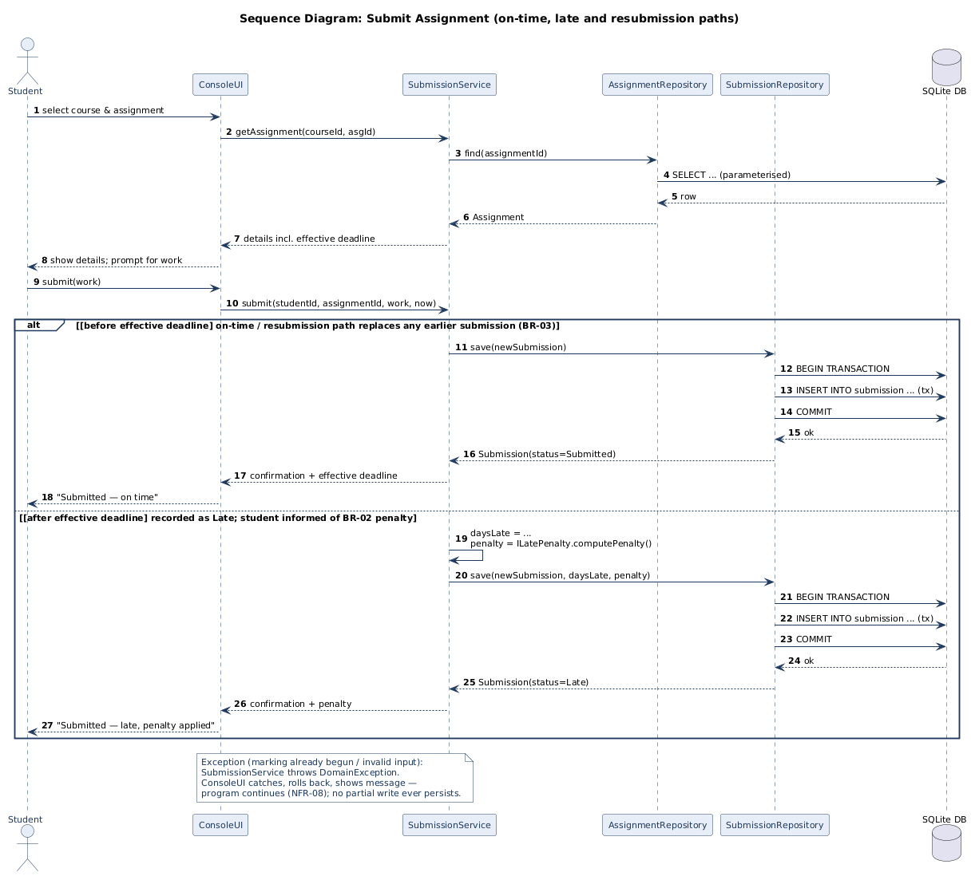

Sequence Diagram 2 - Moderate and Release Marks
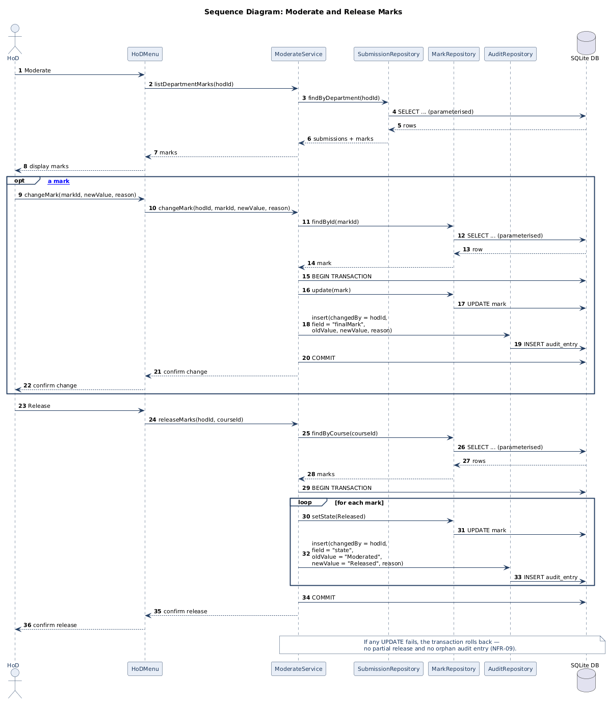
Submit Assignment: A student selects a course and assignment through the ConsoleUI, which asks SubmissionService to load the assignment from AssignmentRepository. The service validates the work and checks the effective deadline: before the deadline the submission is saved as on time, after the deadline the late penalty is computed, and the submission is saved as late. Either way, the write happens inside a single transaction (BEGIN → INSERT → COMMIT) so no partial submission can persist. The service returns confirmation, and the UI shows the student either "on time" or "late, penalty applied". If anything fails, SubmissionService throws a DomainException, the UI rolls back and displays a plain-language message, and the program continues.
Moderate and Release Marks: The HoD asks ModerateService for the department's marks, which fetches from SubmissionRepository and returns for display. If the HoD changes a mark, the service updates MarkRepository and writes an audit entry (changedBy, oldValue, newValue, reason) in the same transaction, so no change can occur without an audit record. When the HoD releases a course, the service loops through every mark, sets its state to Released, and writes one audit entry per mark inside a single transaction. Any failure rolls the whole transaction back, leaving no partial release and no orphan audit entry. The HoD receives confirmation once the release is committed.

Database Design

Entity–Relationship Diagram (ERD)
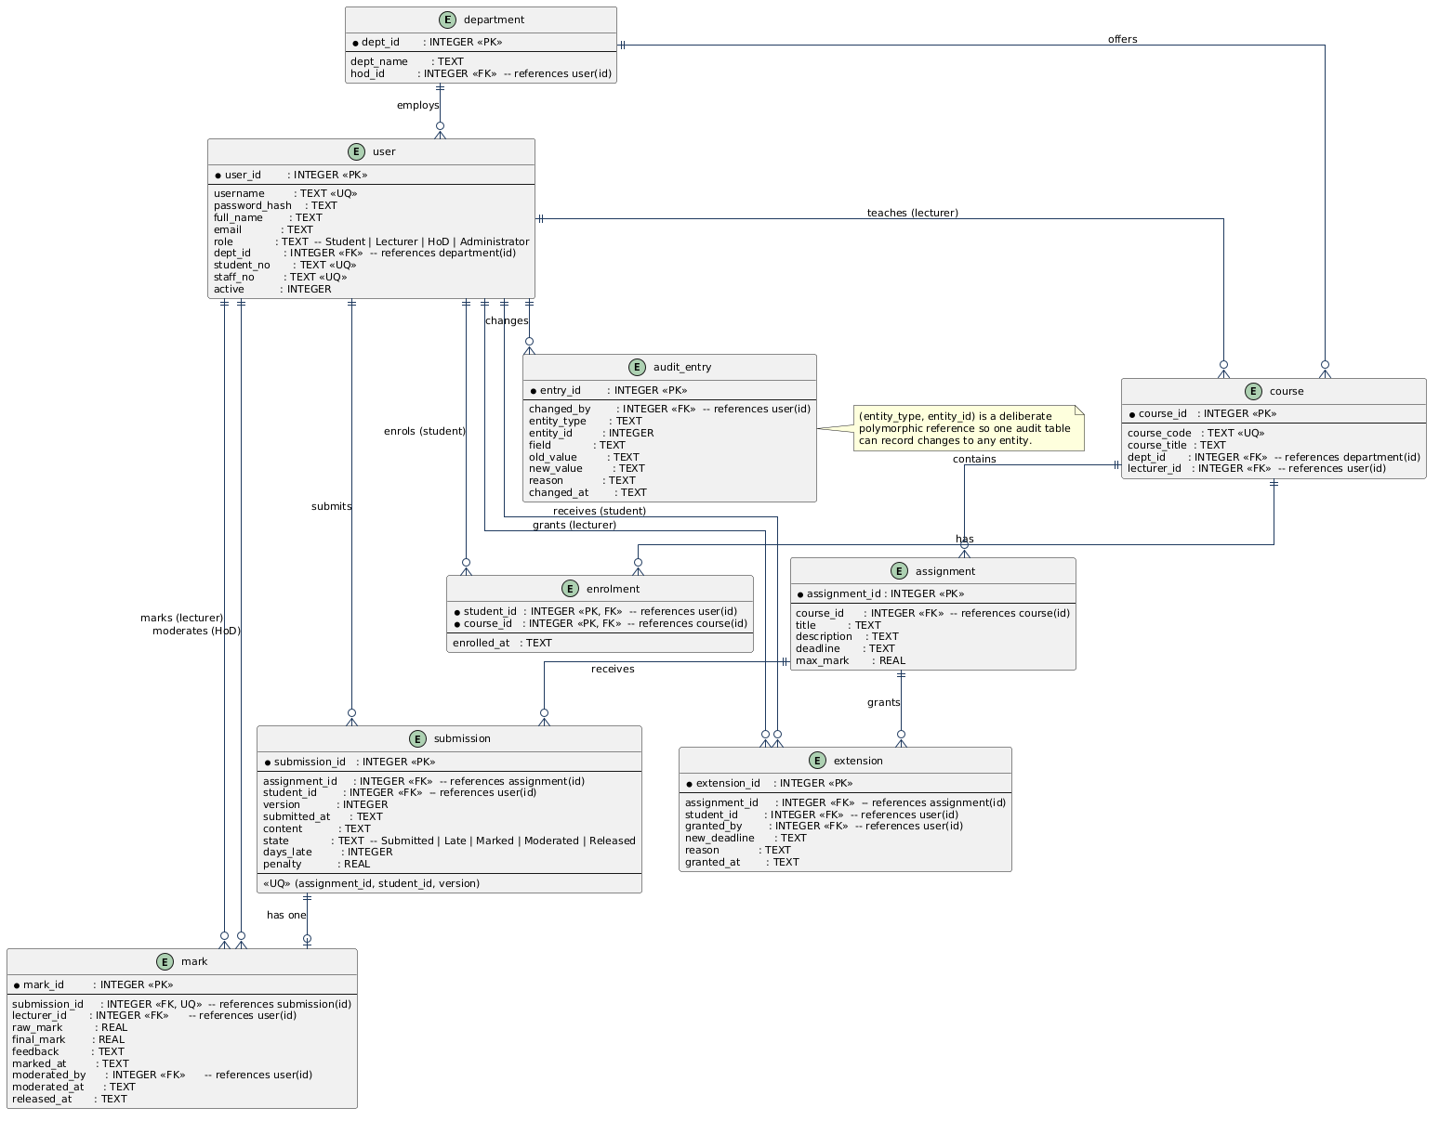
The ERD models the MLMS database in Third Normal Form using eight tables: department, user, course, enrolment, assignment, submission, mark, extension, and audit_entry. Relationships link users to departments, courses to departments and lecturers, students to courses via the enrolment join table, and assignments to submissions, marks and extensions. A submission has at most one mark, and every mark change is recorded in audit_entry with who, when, old value, new value and reason. The design satisfies 1NF, 2NF and 3NF, with one deliberate denormalization: mark.final_mark is stored so the released value stays stable and auditable.

Data Dictionary
Table | Column | Type | Constraints
department | dept_Id, dept_name, hod_id | INTEGER, TEXT, INTEGER | PK, NOT NULL, UNIQUE, FK, NULL
user | user_Id, username, password_hash, full_name, email, role, dept_id, student_no, staff_no, active | INTEGER, TEXT | PK, NOT NULL, UNIQUE, FK,
mark | submission_id, lecturer_id, raw_mark, final_mark, feedback, marked_at, moderated_by, moderated_at, released_at | INTEGER, REAL, TEXT | PK, NOT NULL, UNIQUE, FK
submission | submission_id, assignment_id, student_id, version, submitted_at, content, state, days_late, penalty | INTEGER, REAL, TEXT | PK, NOT NULL, UNIQUE, FK
enrollment | student_id, course_id, enrolled_at | INTEGER, TEXT | PK, NOT NULL, UNIQUE, FK
assignment | assignment_id, course_id, title, description, deadline, max_mark | INTEGER, REAL, TEXT, | PK, NOT NULL, UNIQUE, FK
extension | extension_id, assignment_id, student_id, granted_by, new_deadline, reason, granted_at | INTEGER, TEXT | PK, NOT NULL, UNIQUE, FK
course | Course_id, course_code, course_title, dept_id, lecturer_id | INTEGER, TEXT | PK, NOT NULL, UNIQUE, FK

Indexes:
- idx_user_username on user(username)
- idx_submission_assignment_student on submission(assignment_id, student_id)
- idx_mark_submission on mark(submission_id)
- idx_audit_entity on audit_entry(entity_type, entity_id)
- idx_extension_student_assignment on extension(student_id, assignment_id)

SQL schema
CREATE TABLE department (dept_id INTEGER PRIMARY KEY AUTOINCREMENT, dept_name TEXT NOT NULL UNIQUE, hod_id INTEGER REFERENCES user(user_id));

CREATE TABLE user (user_id INTEGER PRIMARY KEY AUTOINCREMENT, username TEXT NOT NULL UNIQUE, password_hash TEXT NOT NULL, full_name TEXT NOT NULL, email TEXT NOT NULL, role TEXT NOT NULL CHECK (role IN ('Student','Lecturer','HoD','Administrator')), dept_id INTEGER REFERENCES department(dept_id), student_no TEXT UNIQUE, staff_no TEXT UNIQUE, active INTEGER NOT NULL DEFAULT 1 CHECK (active IN (0,1)));

CREATE TABLE course (course_id INTEGER PRIMARY KEY AUTOINCREMENT, course_code TEXT NOT NULL UNIQUE, course_title TEXT NOT NULL, dept_id INTEGER NOT NULL REFERENCES department(dept_id), lecturer_id INTEGER REFERENCES user(user_id));

CREATE TABLE enrollment (student_id INTEGER NOT NULL REFERENCES user(user_id), course_id INTEGER NOT NULL REFERENCES course(course_id), enrolled_at TEXT NOT NULL, PRIMARY KEY (student_id, course_id));

CREATE TABLE assignment (assignment_id INTEGER PRIMARY KEY AUTOINCREMENT, course_id INTEGER NOT NULL REFERENCES course(course_id), title TEXT NOT NULL, description TEXT NOT NULL, deadline TEXT NOT NULL, max_mark REAL NOT NULL CHECK (max_mark > 0));

CREATE TABLE submission (submission_id INTEGER PRIMARY KEY AUTOINCREMENT, assignment_id INTEGER NOT NULL REFERENCES assignment(assignment_id), student_id INTEGER NOT NULL REFERENCES user(user_id), version INTEGER NOT NULL CHECK (version > 0), submitted_at TEXT NOT NULL, content TEXT NOT NULL, state TEXT NOT NULL CHECK (state IN ('Submitted','Late','Marked','Moderated','Released')), days_late INTEGER NOT NULL DEFAULT 0 CHECK (days_late >= 0), penalty REAL NOT NULL DEFAULT 0 CHECK (penalty >= 0), UNIQUE (assignment_id, student_id, version));

CREATE TABLE mark (mark_id INTEGER PRIMARY KEY AUTOINCREMENT, submission_id INTEGER NOT NULL UNIQUE REFERENCES submission(submission_id), lecturer_id INTEGER NOT NULL REFERENCES user(user_id), raw_mark REAL NOT NULL CHECK (raw_mark >= 0), final_mark REAL NOT NULL CHECK (final_mark >= 0), feedback TEXT NOT NULL CHECK (length(feedback) > 0), marked_at TEXT NOT NULL, moderated_by INTEGER REFERENCES user(user_id), moderated_at TEXT, released_at TEXT);

CREATE TABLE extension (extension_id INTEGER PRIMARY KEY AUTOINCREMENT, assignment_id INTEGER NOT NULL REFERENCES assignment(assignment_id), student_id INTEGER NOT NULL REFERENCES user(user_id), granted_by INTEGER NOT NULL REFERENCES user(user_id), new_deadline TEXT NOT NULL, reason TEXT NOT NULL, granted_at TEXT NOT NULL);

CREATE TABLE audit_entry (audit_id INTEGER PRIMARY KEY AUTOINCREMENT, changed_by INTEGER NOT NULL REFERENCES user(user_id), entity_type TEXT NOT NULL, entity_id INTEGER NOT NULL, field TEXT NOT NULL, old_value TEXT, new_value TEXT NOT NULL, reason TEXT NOT NULL, changed_at TEXT NOT NULL);

CREATE TABLE notification (notification_id INTEGER PRIMARY KEY AUTOINCREMENT, recipient_id INTEGER NOT NULL REFERENCES user(user_id), type TEXT NOT NULL CHECK (type IN ('MarkReleased','ModerationReturned','ExtensionGranted')), message TEXT NOT NULL, related_entity_id INTEGER, created_at TEXT NOT NULL, read_at TEXT);

CREATE INDEX idx_notification_recipient ON notification(recipient_id);
CREATE INDEX idx_user_username ON user(username);
CREATE INDEX idx_submission_assignment_student ON submission(assignment_id, student_id);
CREATE INDEX idx_mark_submission ON mark(submission_id);
CREATE INDEX idx_audit_entity ON audit_entry(entity_type, entity_id);
CREATE INDEX idx_extension_student_assignment ON extension(student_id, assignment_id);

Class-to-Table Mapping and Justified Differences
Class | Table | Mapping notes
User (abstract) and its four subclasses | user | Single-table inheritance. The role column distinguishes subclasses; nullable student_no and staff_no are subclass-specific attributes. This avoids four near-identical tables and simplifies UserFactory.
Role (Enum) | user.role | Enum values become a CHECK constraint on the column.
Department | department | One-to-one.
Course | course | One-to-one.
Assignment | assignment | One-to-one.
Submission | submission | One-to-one. The state column stores the SubmissionState enum as text; the enum is mapped in code.
SubmissionState (enum) | submission.state | Enum values become a CHECK constraint on the column.
Mark | mark | One-to-one.
Extension | extension | One-to-one.
AuditEntry | audit_entry | One-to-one.
Enrolment (association class) | enrolment | The many-to-many association between Student and Course becomes an explicit join table with its own attribute, enrolled_at.
Notification | notification | One-to-one. The type column stores the NotificationType enum as a CHECK constraint.
NotificationType (enum) | notification.type | Enum values become a CHECK constraint on the column.
ILatePenalty, StandardLatePenalty, NoLatePenalty | No table | Penalty is a policy, not data. The chosen strategy is selected in code by configuration; the computed penalty is stored in submission.penalty and mark.final_mark for audit purposes.
IUserRepository, ICourseRepository, IAssignmentRepository, ISubmissionRepository, IMarkRepository, IExtensionRepository, IAuditRepository, INotificationRepository | No table | Data-access abstractions. They map rows to domain objects but have no persistent state of their own.
SqliteUserRepository, SqliteCourseRepository, SqliteAssignmentRepository, SqliteSubmissionRepository, SqliteMarkRepository, SqliteExtensionRepository, SqliteAuditRepository, SqliteNotificationRepository | No table | SQLite implementations of repository interfaces. They contain SQL and row-mapping logic but hold no persistent state of their own.
SqliteConnection, TransactionScope, RowMapper, QueryBuilder | No table | Runtime infrastructure for connection handling, transaction scoping, row mapping and query building. No persistent state.
UserFactory | No table | Pure factory logic.
AuthService, AuthorisationGuard, UserAdminService, CourseService, AssignmentService, SubmitService, MarkService, ModerateService, ExtensionService, AuditService, NotificationService | No table | Application-layer services. They orchestrate persistence but have not persisted.

Justified differences
  - Single-table inheritance for User. The four subclasses differ only in a few attributes and behavior. Splitting them into four tables would require joins for login and complicate UserFactory without benefit. The role CHECK constraint preserves integrity.
  - Stored final_mark. The class diagram shows Mark.finalMark as a derived value (raw mark minus penalty). It is stored because BR1 and NFR9 require that the value released to the student be stable and auditable, even if the penalty rule is later changed.
  - Polymorphic audit_entry. The audit log records changes to any entity, so a single table with (entity_type, entity_id) is used instead of one audit table per entity. This keeps the audit write-path uniform and satisfies NFR9 with one transaction per change.
  - Extension is a separate table. Extension is not an attribute of Submission because an extension exists before a submission (it changes the effective deadline). Modelling it separately supports BR3 and BR 4 cleanly.
  - Enrolment as an explicit table. The many-to-many association between Student and Course cannot be represented in 3NF without a join table, called enrollment.
  - Notification as a separate table. Notifications are events with their own lifetime (created, read), so they are modelled as a table rather than as attributes of Mark or Submission. This supports FR21 (notify student when a mark is released) and keeps the NotificationService decoupled from MarkService via the Observer pattern.

References
- Sommerville, I. (2016) Software Engineering. 10th edn. Boston: Pearson.
- CS4433 (2026) CS4433 Final Project — Individual Assignment: Moderated Learning Management System. Moderated Learning Management System (MLMS).
- ISO/IEC/IEEE. (2018). ISO/IEC/IEEE 29148:2018 — Systems and Software Engineering — Life Cycle Processes — Requirements Engineering.
- Boehm, B. W. (1989). Software Risk Management. IEEE Computer Society Press.
- Gamma, E., Helm, R., Johnson, R., & Vlissides, J. (1994). Design Patterns: Elements of Reusable Object-Oriented Software. Addison-Wesley.
- Martin, R. C. (2017). Clean Architecture: A Craftsman's Guide to Software Structure and Design. Prentice Hall.
- PlantUML, n.d. PlantUML in a nutshell. [online] Available at: plantuml.com.

